XY Chart ActiveX Order Form | 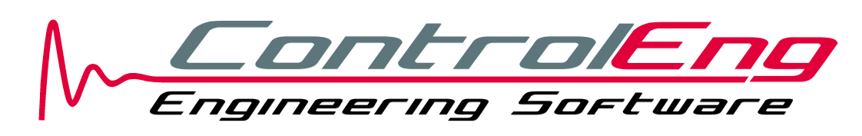 | ControlEng Corporation  80 Sandway Crescent  Maple, Ontario, Canada L6A 2M3  Tel: 1-888-795-8236 (USA & Canada only)  Tel: 416-895-8236  Fax: 905-417-3591

Please complete this form and send it to ControlEng via email, mail or fax.

License Registration & Shipping Information
Name: | Company:
Street:
City: | State/Province:
Zip/Postal Code: | Country:
Telephone: | Fax:
Email:

Product | License ¹ | Price ² ³ | Quantity | Total
XY Chart ActiveX | [ ] 1 License  [ ] 5 Licenses  [ ] 10 Licenses  [ ] 20 Licenses | $299  $879  $1,539  $2,149
Shipping |  | Price ¹ ²
XY Chart ActiveX is shipped free of charge by Internet download.
Sub-Total
Canadian residents add 13% HST
TOTAL

Payment ¹
[ ] Visa [ ] MasterCard [ ] American Express [ ] Discover | Cardholder Name:
[ ] Check [ ] International Bank Draft | Cardholder Address:
[ ] Wire Transfer | City:
Sorry, no Purchase Orders accepted | Province/State:
Sorry, no Purchase Orders accepted | Postal/Zip Code:
Sorry, no Purchase Orders accepted | Country:
Sorry, no Purchase Orders accepted | Card Number:
Sorry, no Purchase Orders accepted | Expiration Date:
Sorry, no Purchase Orders accepted | Signature:

All products include a 30 day satisfaction money-back guarantee.

¹ Mark desired selection with an [X]
² All prices in USD
³ Students and professors can request a 50% academic discount. When placing your order, please include a copy of a currently valid student/faculty ID card or an alternate document proving student/faculty status. All ID cards must clearly indicate the name of the individual, the date of validity and the name of the institution. Finally, the registered email address above must be from the same educational institution.

